**Running a python script in the background in Windows**

1 ) In terminal enter Cron – the scheduler of linux – with ’sudo’ as administrator

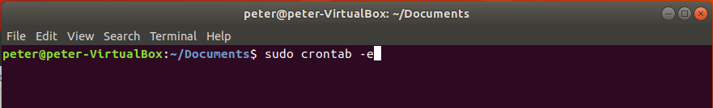

2 ) Add the path of the .py file with @reboot, then save it

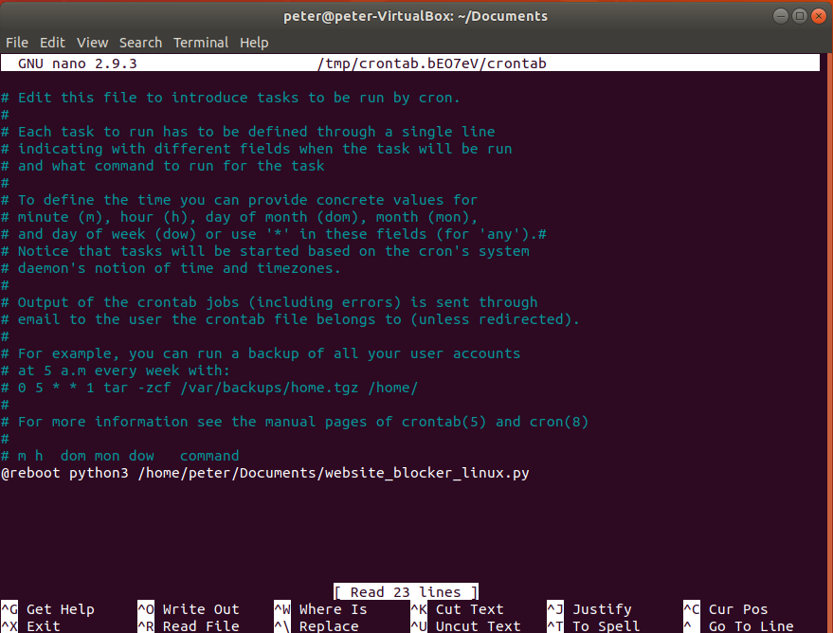

2 ) You can see with „top” or „htop” that the process is running after reboot:

